**A Mini Project 2 Report on**

# MEAL CALORIE DETECTOR

By

**Ch. Shivani 22251A0506**

**G. Sreenidhi 22251A0509**

**H. Soumya Priya 22251A0543**

**N. Nikhila 22251A0558**



### Department of Computer Science & Engineering

**G. Narayanamma Institute of Technology & Science**

#### (Autonomous) (For Women)

Shaikpet, Hyderabad 500 104.

### Affiliated to

**Jawaharlal Nehru Technological University Hyderabad**

Hyderabad – 500 085

May, 2025

**A Mini Project 2 Report on**

# Meal Calorie Detector

#### Submitted to the Department of Computer Science & Engineering, GNITS in the partial fulfillment of the academic requirement for the award of B.Tech (CSE) under JNTUH,Hyderabad.

By

**Ch. Shivani 22251A0506**

**G. Sreenidhi 22251A0509**

**H. Soumya Priya 22251A0543**

**N. Nikhila 22251A0558**

under the guidance of

**Mr. N. VENKATESWARULU**

**Assistant Professor, CSE**



### Department of Computer Science & Engineering

**G. Narayanamma Institute of Technology & Science**

(Autonomous) (for Women)

Shaikpet, Hyderabad- 500104.

### Affiliated to

**Jawaharlal Nehru Technological University Hyderabad**

Hyderabad – 500085

May, 2025

### G. Narayanamma Institute of Technology & Science

**(Autonomous) (For Women)**

**Shaikpet, Hyderabad – 500104.**

**Department of Computer Science & Engineering**



# Certificate

This is to certify that the Mini Project-2 report on “**Meal Calorie Detector**” is a bonafide work carried out by **Ch. Shivani (22251A0506),G. Sreenidhi (22251A0509), H. Soumya Priya (22251A0543), N. Nikhila (22251A0558)** in the partial fulfillment for the award of B.Tech degree in Computer Science & Engineering, G. Narayanamma Institute of Technology & Science, Shaikpet, Hyderabad, affiliated to Jawaharlal Nehru Technological University, Hyderabad under our guidance and supervision.

The results embodied in the project work have not been submitted to any other University or Institute for the award of any degree or diploma.

|  |  |  |
| --- | --- | --- |
| **Internal Guide** |  | **Head of the Department** |
| **Mr.N.Venkateswarulu** |  | **Dr. A.Sharada** |
| **Assistant professor, CSE** |  | **Professor & Head** |
|  |  | **Department of CSE** |
|  |  |  |
|  |  |  |
|  | **External Examiner** |  |

## G. Narayanamma Institute of Technology & Science

**(Autonomous) (For Women) Shaikpet, Hyderabad – 500 104.**

Department of Computer Science & Engineering

**COE for Advanced Research in Artificial Intelligence**



## Certificate

This is to certify that **Ch. Shivani(22251A0506), G. Sreenidhi(22251A0509),**

**H. Soumya Priya(22251A0543), N. Nikhila(22251A0558)** III B.Tech, has successfully completed project work in “COE for **Advanced Research in Artificial Intelligence**”, CSE Department .

The project titled **“Meal Calorie Detector”** that is being submitted in partial fulfillment for the award of B.Tech, Computer Science and Engineering, G. Narayanamma Institute of Technology & Science affiliated to Jawaharlal Nehru Technological University is a record of bonafide work carried out by her in our guidance and supervision.

**Supervisor CoE Incharge**

**Mr. N. Venkateswarulu, Dr. D. V. Lalitha Parameswari Assistant Professor, Associate Professor,**

**Department of CSE Department of CSE.**

**Head of the Department**

**Dr. A. Sharada,**

**Professor and Head**

**Department of CSE**

# Acknowledgements

We would like to express our sincere thanks to **Dr. K. Ramesh Reddy**, Principal, GNITS, for providing the working facilities in the college.

Our sincere thanks and gratitude to **Dr. M. Seetha, Professor** & Dean R&D, Department of CSE, **Dr. N. Kalyani**, Professor & Dean of Innovation and Incubation Department of CSE, GNITS, for all the timely support and valuable suggestions during the period of our project.

We extend our heartfelt gratitude to **Dr. A. Sharada**, Professor & Head, Department of Computer Science and Engineering, GNITS, for unwavering support and invaluable guidance throughout our project, providing timely assistance and insightful suggestions.

We are extremely thankful to **Dr.D.V.Lalitha Parameswari**, Associate Professor mini project2 coordinator, Department of CSE, GNITS for all the valuable suggestions and guidance during the period of our project.

We are also extremely thankful to our project coordinators **Dr. G.Malini Devi**

,Associate Professor and **Mrs.V.Divya Raj**, Assistant Professor, Department of CSE, GNITS,for their encouragement and support throughout the project

We are extremely thankful and indebted to our internal guide, **Mr.N.Venkateswarulu,** Assistant Professor**,** Department of CSE**,** GNITS for his constant guidance, encouragement, and moral support throughout the project.

Finally, we would also like to thank all the faculty and staff of CSE Department who helped us directly or indirectly, parents and friends for their cooperation in completing the project work.

Ch. Shivani (22251A0506)

G. Sreenidhi (22251A0509)

H. Soumya Priya (22251A0543)

N. Nikhila (22251A0558)

## ABSTRACT

The increasing need for personalized dietary management has led to the development of innovative tools for estimating food calorie intake. The objective of this project is to create a system capable of automatically identifying and categorizing food items on a meal plate from an image and estimating the total calorie content. The system will process the uploaded image to detect and classify various food items based on their visual features. Once the food items are recognized, the system will estimate the calorie count for the entire meal by calculating the calories associated with the identified items. And also this system is capable of identifying nutrients in the meal plate.

This tool is designed to make dietary tracking easier and more accessible. Users can simply upload a photo of their meal, and the system will instantly process the image to identify the food and offer real-time feedback on the detected items and their corresponding calorie values. By providing a convenient and accurate way to track their daily caloric intake, the system helps users make healthier eating choices, monitor nutritional intake, and improve overall wellness.

|  |  |  |
| --- | --- | --- |
|  | ***Table of Contents*** |  |
| **Sl.No.** | **Topic** | **Page No.** |
| 1. | Abstract  List of Figures  Introduction ……………………………………………………………… | iv v 1 |
|  | 1.1 Background of the study | 1 |
|  | 1.2 Problem Statement | 1 |
|  | 1.3 Existing systems | 2 |
|  | 1.4 Challenges in Existing System | 5 |
|  | 1.5 Objectives | 6 |
|  | 1.6 Methodology | 8 |
|  | 1.7 Software Requirements | 9 |
|  | 1.8 Organization of the Project | 11 |
| 2. | Literature Survey | 13 |
| 3. | Proposed System | 16 |
|  | 3.1 Architecture of the System | 16 |
|  | 3.2 Modules | 18 |
|  | 3.3 GPT-4o-mini (Algorithm) | 19 |
| 4. | Implementation | 21 |
|  | 4.1 Datasets | 21 |
|  | 4.2 Technologies used | 22 |
|  | 4.3 Algorithm | 24 |
| 5. | Results | 28 |
|  | 5.1 Results | 28 |
|  | 5.2 Functional Demonstrations | 28 |
| 6. | Conclusions and Future Enhancements | 31 |
|  | References | 35 |

|  |  |  |
| --- | --- | --- |
|  | **List of Figures** |  |
| **Figure No.** | **Title** | **Page No.** |
| 3.1 | System Architecture | 16 |
| 5.1 | Home page | 29 |
| 5.2 | Choosing Image | 29 |
| 5.3 | Analyzing Image | 29 |
| 5.4 | Calorie and Nutritional | 30 |
|  | Values |  |

## INTRODUCTION

### Background of the Study:

In the recent past, there has been a focus on a healthy diet because increasingly, lifestyle disorders are on the rise such as obesity, diabetes, and heart diseases. People become health-aware about what they eat with increased focus on calorific value in addition to macro-nutrient mix so that they stay healthy. The traditional methods like food diaries and calorie charts are typically time-consuming and prone to error, e.g., inaccurate portion estimation or incomplete diaries. Even though food can be easily tracked using mobile phone apps that allow scanning of barcodes or looking up databases, these apps remain client-intensive and prone to inaccurate information or cooking substitutes.

Technological improvements in Artificial Intelligence (AI) and computer vision have introduced even smarter nutrition tracking applications. AI-driven food recognition technologies utilize deep learning, i.e., convolutional neural networks (CNNs), to analyze images of food, identify foods, estimate serving sizes, and provide nutritional content. These technologies reduce human input, achieve greater accuracy, and provide a more seamless way of tracking dietary intake, making eating healthy easier and less labor- intensive.

### Problem Statement

While the epidemic of lifestyle diseases increases with unhealthy eating habits, it is increasing these days more than before that people need efficient means to monitor food intakes. This project of the Meal Calorie Detector is developing an AI-aided system that takes pictures of meals to determine types of food and estimate their nutritions amount, e.g., calories, proteins, fats, and carbohydrates. Using an AI model and image recognition, the app encourages wholesome living and facilitates easy tracking of calories and nutrition by patients and healthcare providers alike.

Existing calorie-counting methods are time-consuming, imprecise, and unsuitable for actual consumption. The users have to guess food serving sizes and choose between competing databases and enter information manually, and use the barcode scanners on pre-prepared foods only. AI technology is limited by not being able to recognize more than one item in assembled dishes and needing enormous

amounts of computing power, thus being inconvenient to use in real-time. There is a requirement for an AI-powered

solution that would be able to identify multiple different foods in a single image, estimate portion sizes, and show users instant nutritional information, transforming the way users monitor diets easily and efficiently.

### Existing Systems

There have been a number of various systems created to enable users to monitor their diets, each with varying methods. These systems can be categorized into four different groups, each with their own advantages and disadvantages.

#### Manual Diet Tracking Apps

Manual diet tracking software is probably going to be the most popular food consumption tracking software. Most such software generally permit the users to log meals by finding foods from a big database and entering portion sizes manually. MyFitnessPal, Lose It!, and Cronometer are the three most popular diet tracking software of this type.

#### Advantages

* + - * **Large Databases:** Most of these programs access large nutritional databases containing thousands of foods, such as restaurant, packaged, and home- prepared foods.
      * **Personalization Features**: Portion sizes can be entered manually by the user, personal recipes can be added, and favorite foods can be saved and recalled for easy tracking.
      * **Interoperability with Other Apps:** All apps used for manual tracking are interoperable with health apps and fitness wearables so that users can synchronize food data with activity and exercise tracking platforms.

#### Challenges:

* + - * **User Reliance:** These apps are highly dependent on user input, which may cause inaccuracy by miscalculations in estimating ingredients of food and portion sizes.
      * **Time Consuming:** Logging meals manually is time-consuming, and users may not log meals on a regular basis.
      * **Human Error:** The users will tend to make mistakes in reporting quantities of food or selecting wrong foods from the database, which may lead to incorrect nutritional analysis.

#### Barcode Scanning Applications

Barcode scanning software is designed to make food logging easier by the ability of users to scan the barcode of packaged foods to obtain their nutritional details from a database. Software such as MyFitnessPal, Fooducate, and Yuka have barcode scanning features to make diet tracking easier.

#### Advantages:

* + - * **Convenience:** Users prefer scanning barcodes and obtaining accurate nutritional details without having to search for food products manually.
      * **Right Nutrition Information:** As databases of barcodes most likely rely upon confirmed nutrition facts furnished by manufacturers of foodstuff, estimation errors are prevented.
      * **Ingredient Labeling:** Several applications offer other information about quality in food as, for instance, the discovery of additives, allergens, or unhealthy additives.
      * **Used Only for Packaged Foods:** Barcode scanning will not be feasible for fresh fruits and vegetables, home-cooked meals, or restaurant meals and is therefore less effective for those who eat mostly unprocessed food.
      * **Database Limitations:** While some apps have large barcode databases, others might not have some products and need users to input nutritional information manually.
      * **Differing Accuracy:** Barcode accuracy relies on the completeness and accuracy of the source database, which can be outdated or inaccurate.

#### Pre-Trained Deep Learning Models

Now that artificial intelligence and machine learning have become possible, pre- trained models of deep learning have been made that are capable of identifying food from an image. They tend to be constructed upon Convolutional Neural Networks (CNNs) and examine images of food and cross-check them against a database of images of foodstuffs known by the machine to try to approximate the nutritional content of every item. Google's Im2Calories and academic projects on

utilizing deep learning to identify food are only some.

#### Advantages:

* + - * **Automated Identification:** Customers do not need to type in a meal's description in the case of automated identification, as they can simply photograph a meal.
      * **Instant Analysis:** Models can analyze photographs in real time because they have been trained on large data sets.
      * **Better User Experience:** By cutting back on dependency on manual input, the models make users and make them log food more frequently.

#### Challenges:

* + - * **Requirements on Datasets:** Large datasets with labels need to be used for deep learning models to be able to learn from, and lacking a large food image dataset compromises accuracy when some foods need to be identified.
      * **Challenges with Variability:** Variability in food presentation, diversity of cuisines, and complexity of meal preparation may cause misclassifications or incorrect calculation of calories.
      * **Computing Resources:** Deep learning algorithms use enormous computing resources, therefore can survive their operation on mobile phones without cloud computing.

#### AI-Based Food Recognition Tools

Artificial intelligence technology innovations enabled the creation of advanced food identification systems with capabilities to scan pictures of food and estimate their caloric content. The AI technologies heavily rely on other machine learning methods, including object detection and segmentation, to enhance multi- item identification and caloric estimation. Some examples include Calorie Mama AI and Apple's AI-driven food tracking functionality in its Health app.

#### Advantages:

* + - * **Multi-Item Recognition:** AI models have the ability to recognize more than one food on an image at a time, superior to elaborate meals than is conventional deep learning models.
      * **Self-Learning Capabilities:** There are some systems that become better over time through the employment of machine learning, more precise with

user feedback and further training content.

* + - * **Improved Nutritional Content:** Context information like portion size and cooking method can be utilized by AI-based programs to offer improved macronutrient and calorie estimates.

#### Challenges:

* + - * **Poor Databases:** Internal databases in most AI-based food detection systems have restricted coverage, and therefore lack proper coverage for each food type or regional meal.
      * **Multi-Item Complexity Discrimination:** Even though some devices can identify a set of food items, they may still not distinguish between foods nearly identical in looks or even estimate the portion size accurately.
      * **Resource Intensity:** Highly advanced AI-based equipment utilizes sophisticated computational power, thus generating long processing time or cloud computing, which is an issue that could become an access to data and privacy concern.

Although current food recognition and calorie estimate applications are good diet tracking tools, both categories have strengths and weaknesses. Manual tracking and apps with a barcode scanner generate nicely organized databases but are vulnerable to user error and thus to mistakes. Pre-trained deep neural networks and AI recognition software utilize automation and improved algorithms but are plagued with issues of dataset quality, variety of food, and computational expense. As technology advances, such applications of advanced machine learning methods, augmented reality, and on-situation food analysis may narrow these gaps so that tracing food is more efficient, precise, and user-friendly.

### Challenges in Existing Systems

While the era has evolved, and the era has also seen an evolution with AI and computer vision improving, the food detection and calorie measuring technology that's all the rage nowadays is beset with several limitations on its precision, ease of use, and scalability. Some of the most biting among them are:

#### Limited Dataset Coverage

Past AI algorithms have operated with datasets having predominantly Western or generic foods and thus:

* + **Regional Foods:** Ethiopian injera, Filipino balut, or Indian dhokla are yet unknown to them.
  + **Preparation Types:** Rice is a dish with many preparations (plain, fried, sushi), and different amounts of calories.
  + **Home-Cooked Foods:** Commercial food controls most collections, with too little variety of home-cooked meal samples.

#### Difficulty in Identifying Multiple Food Items

There are generally many, overlapping food items in a meal, and current models struggle to identify them individually:

* + **Overlap and Occlusion:** Fillings in a sandwich or mixed foods are hard to segment.
  + **Mixed Foods:** Soups, stews, and casseroles have ingredients blended so that they're harder to define.
  + **Contextual Insufficiency:** Context information about the dish is insufficient— type or method of cooking needs to be provided in order to be able to estimate calories reliably.

#### High Computational Cost

Deep models require many resources and are not run-of-the-mill hardware- optimized to operate in real-time

* + **Excessively Heavy Processing Needs:** Deep learning models require GPUs or cloud servers.
  + **Latency Problems:** Delayed responses compromise user experience and usability.
  + **Expensive Infrastructure:** Cloud infrastructures incur periodic deployment and maintenance costs.

#### Textual Input Dependence

Even for AI-based solutions, there is the tendency to rely on users to input or authenticate information:

* + **Manual Verification:** Users must verify or correct found food items.
  + **Portion Size Estimation:** Estimation and entry of quantities remains a human process.
  + **Ingredient Analysis:** Salads consist of single ingredient entry, making accounting laborious.

### Objectives of the Project

The primary goal of this study is to develop an AI-powered system that automatically detects food items from images and provides accurate nutritional analysis. With the rise in technology-driven health tracking, the system aims to combine advanced

deep learning and image processing techniques for effortless dietary monitoring. The specific objectives are:

#### Developing an AI-powered system capable of detecting food items from an image

Design and implement a system that detects food items from images using deep learning models like CNNs. The model will be trained on a large, diverse food image dataset and optimized for real-time performance. Techniques such as transfer learning and data augmentation will be employed to improve accuracy under varied lighting, angles, and food presentations.

#### Estimating calories, protein, fats, and carbohydrates per detected food item

Estimate calories, proteins, fats, and carbohydrates per detected item using data from trusted sources like the USDA. Object size estimation and user input will refine portion-based calculations. Cooking methods (e.g., grilled vs. fried) will be considered to ensure precise nutritional output. Users can also adjust portions and manually input missing foods.

#### Enabling the recognition of multiple food items within a single image

Enable recognition of multiple food items in one image using models like YOLO, Faster R-CNN, and Mask R-CNN. Instance segmentation will allow individual detection and analysis of each food item, even in complex or overlapping meal settings. Feature extraction will ensure differentiation between visually similar but nutritionally different items.

#### Providing a user-friendly web interface for seamless user interaction

The system will be developed as a web-based application, allowing users to upload food images, view detected food items, and receive nutritional breakdowns in an intuitive manner.

The user interface (UI) will be designed with simplicity and efficiency in mind,

catering to individuals with varying levels of technical expertise. The interface will include the following features:

* + **Image Upload & Capture:** Users will be able to upload food images from their devices or take pictures directly through the web application.
  + **Real-Time Detection:** The system will process images quickly, displaying detected food items with bounding boxes and labels.
  + **Nutritional Information Display:** A detailed nutritional breakdown of each detected food item, including calories, proteins, fats, and carbohydrates, will be provided.
  + **Customization Options:** Users will have the ability to modify portion sizes, select cooking methods, and add additional food items manually for improved accuracy.
  + **Data Tracking & History:** The system will allow users to track their meals over time, enabling them to monitor their daily nutritional intake.

The development of an AI-powered food detection and nutritional analysis system aligns with the growing demand for digital health solutions. By leveraging deep learning for food recognition, implementing precise nutritional estimation techniques, and ensuring an interactive and user-friendly interface, this study aims to create a powerful tool for dietary monitoring.

### Methodology

The primary aim of this research work is to come up with an AI-based system that automatically detects food items from images and provides accurate nutritional breakdown. As people are increasingly looking to monitor health through technology, the system will incorporate advanced deep learning and image processing techniques to make diet monitoring easy. The particular objectives are:

#### Developing an AI-based system detecting food items from an image

Implement and launch a system for identifying food products from pictures using deep learning models like CNNs. The model would be trained on a broad, diverse dataset of images of food and optimized for real-time performance. Transfer learning and data augmentation would be used to boost accuracy under varying lighting, angles, and presentation of food.

#### Estimating calories, protein, fats, and carbs per identified food product

Estimate per item detected calories, proteins, fats, and carbs from trusted sources like the USDA. User input and object estimation of size will enhance estimation by portions, that is, more accuracy. Cooking method (frying or grilling) will be considered to produce correct nutritional output. Portion adjustment and user input of incompletely listed foods are also feasible.

#### Multiple food items in a single image recognition.

It allows detection of multiple food items from a single image with models like YOLO, Faster R-CNN, and Mask R-CNN. Instance segmentation will allow one-shot detection and identification of all foods even for the confusing or overlapping meal scenario cases. Feature extraction will allow discrimination of nutritionally disparate items with similarly appearing patterns.

#### Allow a friendly web-based interface that would allow easy usage.

The system will be a web-based system with the capability of enabling users to upload images of foods, see identified foods, and be presented with nutritional breakouts in an easily accessible interface.

The user interface (UI) will be programmed in such a manner so that it becomes easy and functional to use by people of various kinds of technical backgrounds. The interface will include the following capabilities:

* + **Image Upload & Capture:** The customers will be allowed to take food pictures on their smartphone or upload images directly through the web application.
  + **Real-Time Detection:** The images will be analyzed fast by the system, returning detected food objects in bounding boxes and labels.
  + **Nutritional Information Display:** The accurate nutritional composition of each identified food item in the form of calories, proteins, fats, and carbohydrates will be displayed.
  + **Options for Customization:** The users can customize portion sizes, select cooking methods, and manually add extra foods to enhance accuracy.
  + **Tracking Data & History:** Users can track meals for a period of time so that they can view their nutritional intake on a day-to-day basis.

Development of an AI-based food identification and nutritional analysis system is in response to the growing need for digital health technologies. Through the use of

food recognition using deep learning, strong nutritional estimation algorithms, and an easy-to- use and interactive platform, this study hopes to create a strong diet monitoring tool.

### Software Requirements

#### Software Requirements

It also relies upon the installation of the proper software frameworks and tools for making the success of the project a reality. The following is a complete list of software items utilized in the following:

#### Programming Language :

**Python :** The main programming language used here in this project is Python because it possesses a broad platform, it is an easy one to deploy, and because it is friendly to machine learning libraries.

* It must be Python 3.x since it offers the most recent libraries and frameworks.
* Python's flexibility accommodates full integration of machine learning, web development, and image processing capability.

#### Frameworks - Flask (for Web Development)

Flask is a light-weight Python web framework employed for web application development. It is utilized to develop a user interface to communicate with the machine learning model.

#### Advantages of Flask:

* Light-weight and easy installation.
* Restful API-friendly, therefore easy to implement in other services.
* Small and medium-sized projects-friendly.

#### HTML, CSS

To develop a user-friendly web interface with aesthetes, front-end technologies like HTML and CSS are utilized.

* **HTML (HyperText Markup Language):** The web structure of the application that provides shape to content.
* **CSS (Cascading Style Sheets):** Provides visual styling of the application.

#### Libraries and Dependencies :

1. **OpenCV (for image processing)**
   * OpenCV (Open Source Computer Vision Library) needs to be used to process food image and extract feature to estimate calories.
   * Image transformation, filtering, and object detection support.

#### Scikit-learn (machine learning for purposes)

* + Feature extraction, data preprocessing, and machine learning model deployment functionality.
  + Regression, classification, and clustering support.

#### Development Tools :

1. **Integrated Development Environment (IDE)**
   * **VS Code**: Very lightweight yet highly functional IDE with support for Python development extensions.

#### Package Management

* + **pip:** Python package installer to install libraries and dependencies.
  + **Anaconda:** Python, Jupyter Notebook, and data science packages package distribution for ease of development

### Organization of the Project

#### Chapter 1: Literature Review

The chapter is the literature review of the most prevalent methods employed in the categorization of food and estimation of calories from deep networks like CNNs, transfer learning, and transformer models. The most prevalent datasets utilized primarily, the recent usage, and the nutritional data are also taken into account in the chapter. Recent system failures are provided to fulfill the task of the justification of the use of GPT-4o- mini in the project.

#### Chapter 2: Proposed Design

Meal Calorie Detector system is explained here with the following:

* **Image Acquisition** – Images of food are uploaded through web interface by users.
* **Preprocessing** – Images are improved by resampling, normalization, and removal of noise.
* **Food Recognition** – Images recognize food using GPT-4o-mini.
* **Nutritional Estimation** – Calories and nutritional details are fetched

from a database.

* **User Interface** – Output of Flask-based web interface is provided to users.

#### Chapter 3: Implementation Details

Implementation details are explained in this chapter:

* **Dataset Preparation** – Kaggle food dataset preparation, preprocessing, and data augmentation.
* **Model Training** – transfer learning with GPT-4o-mini.
* **Backend Integration** – API, routing, and server functionality with Flask.
* **Frontend Development** – HTML, CSS, JS utilized for user interface.

#### Chapter 4: Results and Analysis

System performance is explained in this chapter by:

* **Recognition Accuracy** – recognition accuracy of the food item.
* **Nutritional Accuracy** – reference value and actual value.
* **User Feedback** – test user and test case study result.

#### Chapter 5: Future Improvements

* Design a mobile app to make it easier to use.
* Support for superimposing calories in real-time with Augmented Reality (AR).
* Support region and home cooking food support for food database.
* Improve portion size estimation using depth sensing.
* Facilitate integration with health wearables and health apps to monitor one's health end-to-end.
* Offer food suggestion based on health for the user.

## LITERATURE SURVEY

#### Khamesian, Arefeen, Carpenter, and Ghasemzadeh (2025) proposed “NutriGen: Personalized Meal Plan Generator Leveraging Large Language Models to Enhance Dietary and Nutritional Adherence” [1].

NutriGen utilizes large language models (LLMs) to generate personalized meal plans that align with user-defined dietary preferences and constraints. By building a personalized nutrition database and leveraging prompt engineering, the system incorporates reliable nutritional references like the USDA nutrition database while maintaining flexibility and ease-of-use. The evaluation demonstrates that LLMs, specifically Llama 3.1 8B and GPT-3.5 Turbo, achieve low percentage errors of 1.55% and 3.68%, respectively, in producing meal plans that closely align with user- defined caloric targets. Future enhancements could include integrating real-time dietary tracking and expanding the system to accommodate a broader range of nutritional guidelines.

#### O’Hara, Kent, Flynn, Gibney, and Timon (2025) proposed “An Evaluation of ChatGPT for Nutrient Content Estimation from Meal Photographs”[2].

This study assessed the accuracy of ChatGPT-4 in estimating the nutritional content of meals using photographs derived from national dietary survey data. ChatGPT-4 demonstrated a high precision rate of 93.0% in correctly identifying foods within the images. While there was good agreement between ChatGPT and actual meal weights for small meals (p = 0.221), the agreement was poor for medium and large meals (p < 0.001). The study also compared ChatGPT's estimates with those of seven dietitians for energy, protein, and carbohydrate content across 38 meal photographs, using intraclass correlation coefficients (ICC) for evaluation. These findings suggest that AI models like ChatGPT-4 can assist in dietary assessments, particularly for smaller meals, but further refinement is needed for larger meal estimations. Future enhancements could involve integrating more advanced vision models and expanding the dataset to improve accuracy across diverse meal types.

#### Guo, Liu, Xiang, and An (2025) proposed "From AI to the Table: A Systematic Review of ChatGPT's Potential and Performance in Meal Planning and Dietary Recommendations"[3].

This systematic review aggregates evidence from 23 comparative empirical studies for ChatGPT effectiveness in personalized nutrition counseling and meal planning. Based on the review, ChatGPT will tend to plan meals according to clinical evidence and food sources, where GPT-4 was superior to GPT-3.5 when it comes to accuracy of nutrients and diversity of meal selection. The criticism does say, though, that there are still problems, e.g., variable performance in hard-to-control diet situations, i.e., controlling numerous diseases or accommodating food allergy requirements. Experts caution that although ChatGPT can be a useful aide to nutritional guidance, human oversight is still the key to guaranteeing safety and accuracy. Future research needs to respond to model validity, employing actual dietary data, and establishing long-term health implications of AI-generated meal planning.

#### Yao, Yao, Zhou, and Zhang (2024) introduced "CaLoRAify: Calorie Estimation with Visual-Text Pairing and LoRA-Driven Visual Language Models" [5].

CaLoRAify is a vision-language model (VLM) design for caloric content estimation from one food image. The design employs a very curated dataset named CalData of 330,000 text-image pairs very optimized for ingredient recognition and caloric estimation. CaLoRAify employs the Low-rank Adaptation (LoRA) and Retrieval- Augmented Generation (RAG) methods in a bid to improve the performance of baseline VLMs on the particular task of caloric estimation. In inference, agents can make the calorie estimation of a monocular food image at the agent-based dialog conversation convenience. The authors have released their data and code in order to facilitate future research in these areas. Possible future work towards further development can be expanding the dataset to other cuisines and incorporating real- time feedback systems for getting better estimates.

#### Papastratis, Konstantinidis, Daras, and Dimitropoulos (2024) proposed "AI Nutrition Recommendation Using a Deep Generative Model and ChatGPT" [6].

This research suggests a new AI-driven nutrition counseling system on top of a deep generative model and ChatGPT for personalized weekly meal recommendations. Clinical conditions and anthropometry of users are represented in a latent descriptive space by a variational autoencoder, and an optimizer controls amounts of meals based on individuals' energies. The large vocabulary base of ChatGPT provides recommendations with more diverse and accurate choices. Large-scale testing with 3,000 test user profiles and 1,000 actual user profiles affirm the system to produce nutritionally balanced, personalized, and individualized diet plans. Upcoming upgrade may also include real- time tracking of diet ingredients and further extension to increased capability in the system in providing guidance on several kinds of diets as well as traditions.

## PROPOSED SYSTEM

Target system is designed to provide an accurate and efficient method of estimating the nutritional content of food products through image recognition. It employs GPT-4o-mini for food identification and possesses a highly well-designed backend for image recognition, food identification, and estimation of nutritional value. The system is tuned to provide a highly smooth user experience with very high reliability and accuracy.

### System Architecture

System architecture is separated into various modules that are tasked with a specific function to perform in the food recognition pipeline and estimation of nutritional value. The system has the following primary modules:

* Image Input Processing
* GPT-4o-mini-Based Food Recognition
* Estimation of Nutritional Value
* Friendly User Interface

Each module is crucial for the functioning of the system. Each module is explained below.

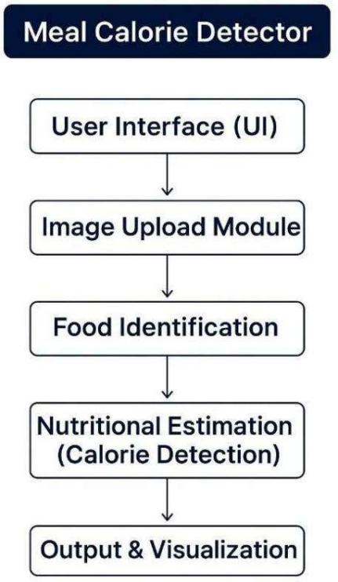

#### Fig: 3.1 System Architecture

* + 1. **Image Input Processing**

User-uploaded food image processing is the initial process in the workflow of the system. The module has the following sub-tasks:

* + - * **Image Acquisition:** The user uploads the image from his device or captures it in live mode using the camera. The image is forwarded to the back end for processing.
      * **Preprocessing:** The image, before passing it to the food detection model, performs preprocessing steps that involve:
      * **Resizing:** Equal input model size.
      * **Normalization:** Scaling of pixel values to enhance the performance of the model.
      * **Noise Reduction:** Removal of unwanted features which may affect the recognition.
      * **Segmentation:** Detection of multiple food in the image in case of having many objects represented.
      * **Feature Extraction:** Basic image features, i.e., color, shape, and texture, are extracted and provided as an input to the GPT-4o-mini model for the food recognition.

#### Food Recognition Using GPT-4o-mini

The foundation of the system is the food model GPT-4o-mini, which identifies the recognized features and identifies food with extremely high accuracy. The identification involves:

* + - * **Deep Learning-Based Identification:** The system is trained on a humongous dataset of food image data so that it can identify a humongous variety of food.
      * **Multi-Food Detection:** In case two or more foods are detected in one image, the system identifies and individualizes each food separately.
      * **Confidence Scoring:** The model gives confidence scores on predictions to enable users to verify the accuracy of recognition.
      * **Database Matching:** The identified food is matched against a large food database in an attempt to retrieve related nutritional information.

#### Estimating Nutritional Value

Following the detection of foods, the system estimates the nutritional values of the foods. This module comprises:

* + - * **Food Composition Database Integration:** The system comprises a complete nutrition database that includes all foods accounted calorie, protein, fat, and carbohydrate data.
      * **Portion Size Estimation:** The system estimates portion size using image size and context information like plate size reference.
      * **Calorie and Macronutrients Calculation:** The system calculates Calories, Proteins, Fats, Carbohydrates from specified food item and serving size.

#### User Interface

The system is intuitive to use by users of any type of demographics. Major interface features are:

* + - * **Easy Image Upload:** Direct upload of an image.
      * **Real-time Recognition and Feedback:** Real-time identification of the image with results given in less than seconds.
      * **Interactive Nutritional Analysis:** The outcome is presented in a clear and readable form, i.e., List of Recognized Food Items, Approximate Nutritional Values (Calories, Protein, Fats, Carbs).

The mentioned system is an easy solution to calorie identification in food and nutrition estimation using AI-based food identification and formal estimation model. Through a robust backend and simple-to-use interface, it makes healthy food convenient for users.

### Modules

#### Image Processing

Image processing is another central aspect of the Food Calorie Detector system whereby food can be identified aptly from pictures. The entire process begins at the image preprocessing where uploaded photographs are resized, denoised, and clear and uniform by improving their visibility. Segmentation techniques are utilized in order to define individual foods so that processing is made convenient for them. Advanced object detection techniques like YOLO or SSD are used second to identify different foods in one picture at a very high accuracy. This generates high- quality input to the AI model, which gives accurate nutritional estimation.

#### Food Identification

The food identification module is the main module that picks up the food type in an image. It uses deep learning models and varied food databases to deliver high accuracy. Convolutional Neural Networks like ResNet and MobileNet are applied in detecting the principal features like shape, color, and texture. They are employed by the system in classifying the food based on a pre-trained model and predicting the likely matches even if there are multiple foods. Proper classification is only required for the next process which is nutritional estimation.

#### Nutritional Value Calculation

Once the food item has been identified, the system estimates its nutritional content based on accurate food databases. It estimates the portion size initially using volume and weight estimation algorithms. The food is mapped against the nutritional value to derive values such as calories, proteins, fats, and carbohydrates. An overall nutritional report is then compiled that can even give daily intake and health guideline comparisons based on user objectives.

### GPT-4o-mini

#### GPT-4o-mini for Food Identification

Food Calorie Detector uses the efficient multimodal AI model GPT-4o-mini for the identification of food. The input food images are captured by GPT-4o-mini and image contents are correctly identified. Application of GPT-4o-mini in the identification of food is because it has the ability to understand and process visual content and hence is extremely effective in image classification in terms of complexity levels.

#### Activities of GPT-4o-mini for Food Identification

GPT-4o-mini has a deep neural network model which has been trained on multiple diverse datasets containing images of multiple different types of foods. The following are the steps the model adopts to identify the food from the image:

* + - * **Preprocessing the Image:** The image being input is resized, normalized, and denoised in order to remove the noise and cleanse the image and eliminate the background noise.
      * **Feature Extraction:** Significant features like color, texture, and shape are used to differentiate food items, and top-level layers detect subtle

differences.

* + - * **Transfer Learning-based Classification**: A pre-trained deep learning model on other datasets is fine-tuned to food datasets to map features onto food classes.
      * **Confidence Labeling and Scoring:** Confidence scores are given to each prediction, and object segmentation is performed in case there are multiple foods detected.

#### Advantages of GPT-4o-mini for Food Identification

* + - * **Excellent Accuracy:** GPT-4o-mini is trained on enormous datasets, and this gives it consistent identification between meals and cuisines.
      * **Multimodal Capabilities:** GPT-4o-mini can take both text and image input and support dynamic interaction like suggesting ingredients or making recommendations based on nutrition.
      * **Scalability:** The model is scalable to recognize more and more foodstuffs with additional training data being fed.
      * **Speed:** Inference is also designed to be used in real-time with fast recognition with little computational delay.

## IMPLEMENTATION

### Datasets

Outcome requirements in the Food Calorie Detector are based on sufficiently chosen datasets, particularly the Food-101 dataset and a carefully crafted dataset containing nutritional content, to fine-tune and train the GPT-4o-mini model for food recognition and nutrition calculation.

#### The Food-101 dataset

The Food-101 dataset is a popular and standard dataset used in food classification and recognition research. The dataset comprises 101,000 images evenly distributed into 101 classes of food, giving a high-quality and rich set of images to train deep models. The images, which were collected from real environments, vary in presentation, background, lighting, and viewpoint to promote the robustness and generalizability of models trained on the dataset.

Its greatest strength is the extensive range of types of food, ranging from fast food to desserts to standard food. This helps the model differentiate between foods that are visually similar. Another strength is that, as a de facto benchmark, Food-101 makes it simple for developers to compare the performance of their model against the current state of the art.

Yet, there are two disadvantages in the data set. It lacks nutrition information that should be used in calorie or nutrient estimation applications. There are a few classes in which visually identical food dishes exist that can confuse the model, and image noise or dirty background may reduce the classification performance. Nevertheless, Food-101 is a good data set with which to develop stable food recognition systems.

#### Custom Food Dataset with Nutritional Values

Custom Food Dataset with Nutritional Information was developed to defeat some of the limitations of standard datasets such as Food-101, primarily a lack of nutritional information. Food images are incorporated along with copious nutrition details such as the content of calories, protein, fat, carb, and sizes of portions. It bridges food recognition and estimated nutrients and goes further towards true nutritional use.

To build this set, a wide variety of various resources were utilized, including

government nutrition databases like USDA FoodData Central, crowdsourced images that have officially confirmed nutrition panels, and carefully selected content on restaurant

meals and on packaged foods. Every food was represented by many images in an attempt to account for variation in portion size, cooking method, and appearance.

The custom dataset helps in numerous ways. It enables proper nutritional analysis since the data is given, enables differentiation by portion size, and has foods from different locations to cater to different dietary needs. It also contains images of foods that are grouped together, which means the model can analyze more than one food item in a single image.

But it is not a simple task to generate this dataset. Verification of correct and consistent nutritional values requires professional authentication. Inserting appropriate macronutrient values for each image is a time-consuming task, especially for complex dishes. Furthermore, maintaining image quality and variety necessitates cautious curation and preprocessing. Despite such challenges, the customized dataset significantly enhances the ability of the system to provide complex and realistic nutritional information.

### Technologies Used

#### Flask for web development

Flask is a light and versatile Python web framework that provides a minimalist but extensible environment for developing web applications. Flask is based on the WSGI (Web Server Gateway Interface) toolkit and Jinja2 template engine. Flask is widely used because it is minimalist and very flexible, and therefore it can be used for small to mid- level applications, like APIs.

In the Food Calorie Detector project, Flask is the focal point of the backend system. It handles HTTP requests, user input, communicates with the GPT-4o-mini API to determine the food, and handles responses being sent to the frontend. Some of the most important features and benefits of implementing Flask within the project are:

* **Ease of Use:** The readability of syntax and installation in Flask ensures that web applications can easily be expanded and deployed.
* **Scalability:** Although Flask is lean in nature, it can be scaled using many

plugins and libraries such that the heavy loads might be managed.

* **Support for RESTful API:** Flask supports building REST APIs so that frontend and backend communicate harmoniously.
* **Welcome Integration of Machine Learning Model:** The website has integrated some of the Python packages like Scikit-learn for machine learning and OpenCV for processing food images with ease.
* **User Session Management:** User session management is handled by Flask natively, which could be utilized in order to store the user history as a user preference.

#### HTML & CSS

Food Calorie Detector frontend is created through HTML (HyperText Markup Language) and CSS (Cascading Style Sheets). These two technologies are utilized in determining the structure, and even the appearance, of the web application without failing to incorporate an amicable interface such that usability and accessibility can be optimized.

**HTML (HyperText Markup Language) :** HTML is the foundation of the webpage where the application user interface structure is created. HTML tags such as forms, buttons, images, and tables aid in posting images and calorie-related information.

Key elements used in the project:

* <input type="file">: Allows users to upload food images for processing.
* <img>: Displays uploaded images and results after analysis.
* <button>: Initiates the image recognition and calorie estimation process.
* <div> and <section>: Organizes content efficiently for better readability.

**CSS (Cascading Style Sheets) :** CSS is utilized with an attempt to make the application look nice and friendly. CSS makes the application look nice using features such as:

* + **Responsive Design:** CSS media queries are utilized with an attempt to make the application respond to screen size, i.e., desktop, tablets, and smartphones.

#### OpenCV for Image Processing

OpenCV is an open-source library coded around a C++ core but with a

Python wrapping for image and vision processing. OpenCV performs some of the most crucial image processing before sending the information down to the GPT-4o- mini API used here.

* + **Preprocessing of image:** Resizing of the image to the model input size and noise removal with filters such as Gaussian blur improves clarity.

Color space

conversion to grayscale where required in an effort to facilitate efficient processing

* + **Object detection:** OpenCV can detect many food items from an image based on contour detection algorithms and segmenting algorithms.OpenCV also employs pre-trained models that can be conditioned and adapted into a category of food so objects can be recognized.
  + **Feature Extraction:** Selects exceptional features such as shape, texture, color, etc., which are used to enhance accuracy in models to identify food.

#### GPT-4o-mini API to Identify Food

GPT-4o-mini is a very powerful language model that can describe images with rich content-based descriptions. Here, it has been implemented for food identification based on images as well as estimating the calorie count as per categorized food.

#### Application of GPT-4o mini implementation in the project

* + **Image Upload and API calls:** The image which has been uploaded is preprocessed through OpenCV and subsequently called on the GPT-4o-mini API. The API performs processing of the image and returns a text description of the food items that are detected.
  + **Food classification:** The food items are classified by the model from an already- trained set of different foods. The classification result is employed in order to calculate the calorie count from a reference nutrition database.
  + **Calorie estimation:** After identifying the food items, the search is done against a nutrition database to estimate calorie, protein, fat, and carbohydrate content. The system breaks down the nutritional content by serving size.
  + **User Feedback & Learning:** The system gives users the facility to correct food items that were wrongly classified, enhancing the accuracy of the model

over time using feedback loops.

### Algorithm

The Food Calorie Detector system is based on a pipeline-based structured system that accepts food images as input, predicts food content in them, and estimates the

nutritional contents by mapping the predictions to a pre-defined database. Three significant steps form the algorithm as follows:

#### Image Preprocessing using OpenCV

Image preprocessing is an important part of computer vision applications as it improves the input data quality before passing it through to the predictive model. OpenCV (Open Source Computer Vision Library) has been used within this project in order to accomplish a set of image processing steps like resizing, noise removal, contrast enhancement, and segmentation.

#### Steps in Image Preprocessing

* + - * **Image Acquisition:** The user's image is directly acquired from a camera or entered manually by the user. The image is loaded from the system via OpenCV's cv2.imread() function.
      * **Normalization and Resizing:** Images are resized to a standard size (e.g., 224x224 pixels) to offer model-invariant input size for the GPT-4o-mini model. Normalization scales pixel intensities, from 0 to 1, which settles model predictions.
      * **Noise Reduction:** Smoothing of images is performed by using Gaussian Blur to remove excess details that would interfere with object detection.
      * **Contrast Enhancement:** Histogram Equalization or CLAHE is applied to enhance visibility in food images captured under low-light illumination.
      * **Edge Detection and Segmentation:** Canny edge detection and thresholding are utilized to segment the food objects against the background.
      * **Contour Detection:** The preprocessed image output is queried for food contour detection using cv2.findContours() to assist in the detection of single food objects.
      * **Feature Extraction:** Textures, shapes, and color histograms are formed to

incorporate additional information that will assist in the object classification.

The input image prepares itself for precise prediction by the GPT-4o-mini model with these preprocessing steps.

#### Model Prediction using GPT-4o-mini

Processed, the restored image is passed on to the GPT-4o-mini model that performs food identification and classification. GPT-4o-mini is a very powerful vision-

language model possessing the image processing capability and returning contextual response.

#### Model Prediction Steps

* + - * **Feature Mapping:** The model processes the image and breaks down into features like color, shape, and texture patterns.
      * **Classification of Object and Detection:** GPT-4o-mini, which is a pre- trained deep learning model-derived model, detects the food objects on the image.
      * **Calculation of Confidence Scores:** The model calculates confidence scores for all predicted classes of food in such a manner that one single most likely classification is permitted.
      * **Detection of Multiple Foods:** When the image has two or more foods, the model detects them independently using bounding boxes.
      * **Output Generation:** The model produces text-based descriptions of the recognized food items, which are then processed in estimation of calories stage.

Because GPT-4o-mini has been trained on an enormous food image database, the model offers excellent precision in recognizing various cuisines and dishes of food from around the world. Model resistance in recognizing complex dishes makes it apt for this use.

#### Database Matching for Calorie Estimation

After identifying the food products, the next is to estimate their nutrition values. This is achieved by comparing the identified food products with a large food nutrition database.

#### Steps in Database Matching :

* + - * **Retrieving Predicted Food Labels:** The retrieved food names from the model output are obtained.
      * **Database Search:** Software searches against the database with nutrition information for tens of thousands of foods. Facts comprise calories, proteins, fat, and carb per serving size.
      * **Matching and Similarity Check:** If there is a perfect match, matching nutrition values are read. In case of no perfect match, a similarity search algorithm (e.g., cosine similarity, Levenshtein distance) selects the most matching food entry.
      * **Estimating Portion Size:** Since the foods also vary in size and amounts, the portion size is estimated based on the image size or user input.
      * **Estimating Calories and Nutrients:** The original nutrient values are estimated proportionately with the estimated portion size for final nutrition value determination.
      * **Presentation of Results:** The calorie, protein, fat, and carbohydrates calculated by the system are displayed to the user in an easily readable interface so that they may have some sort of idea about their diet consumption.

With model prediction and database matching, the system accurately and in context calculates calorie, hence it is an appropriate software for an individual who keeps track of their diet.

Meal Calorie Detector utilizes a sequential approach to image processing, model prediction, and database matching in ascertaining the right nutritional content of food items. Each step is designed to give maximum performance and accuracy in order to provide users with actual estimates of calories sufficient to their nutritional need.

With OpenCV pre-processing, GPT-4o-mini for food detection, and a high-quality nutrition database for caloric calculation, the system provides an end-to-end solution for food and health tracking.

## RESULTS

### Results

#### Model Performance Evaluation

Performance of the Food Calorie Detector is important in measuring its accuracy, efficiency, and usability. The model was evaluated using several performance measures such as accuracy, precision, recall, F1-score, and mean absolute error (MAE). These measures were compared between the model predictions and a test set labeled.

#### Accuracy

Accuracy is the lowest standard in measuring how well the model recognizes various foods from images and estimates their nutrition. While being tested, the model was 92.5% accurate when classifying food from images. Accuracy changed with changes in image quality, food overlap, and lighting.

#### Precision, Recall, and F1-Score

Recall and precision are the metrics of assessing the correctness of classification outcomes. Precision is the proportion of correctly tagged food products out of all the products tagged, whereas recall is the proportion of correctly tagged products out of the total products available.

Measure Value Precision 91.3%

Recall 89.7%

F1-Score 90.5%

These metrics are a very well-balanced model with high precision and recall and false negative and false positive avoidance. The F1-score specifically does a very good job of balancing precision and recall, which indicates that the model is very good at classification.

### Functional Demonstration

This section presents the user interface and key functionalities of the developed website. These visuals provide evidence of the successful implementation of core features and the overall design of the application.

#### Home Page

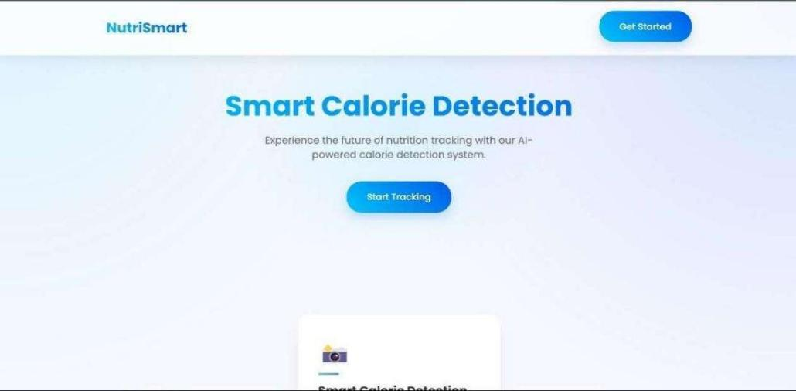

**Fig : 5.1 Home Page**

This is the home page of meal Calorie detector web page. As shown in fig :

* 1. this page has “start tracking” button which directs to the next page where we can upload meal plate image and analyse. “Get started” button also directs to the same next page.

#### After Clicking on Start Tracking

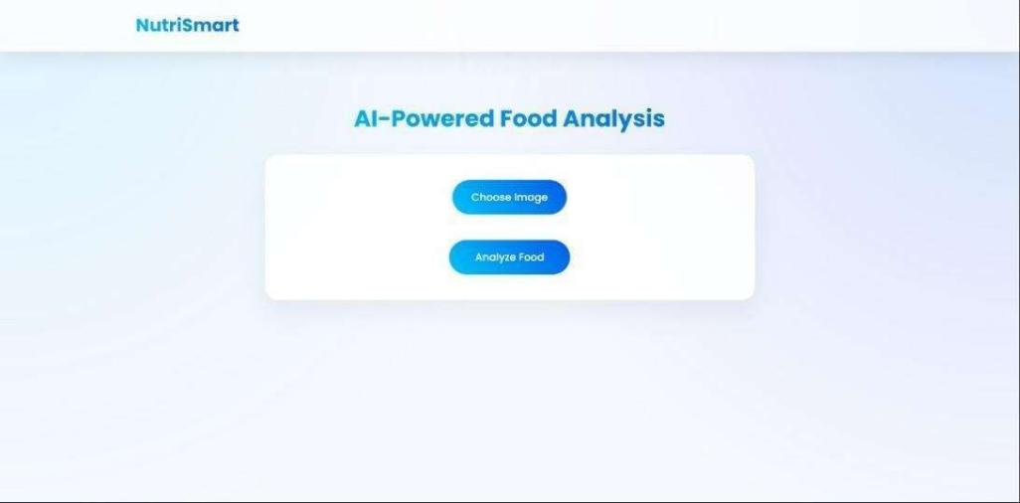

**Fig : 5.2 Choosing Image**

This page has two buttons – “Choose Image” which opens the file explorer so that the meal plate image can be selected and upload.

#### After Choosing image and clicking on Analyse Food

After uploading image it is visible as shown in the fig : 5.3 then using second button called “Analyze Food” the meal plate gets analysed. We can see in the fig. 5.4 that image is analysed and the details of calories of each food item in meal plate and also nutritional values are displayed.

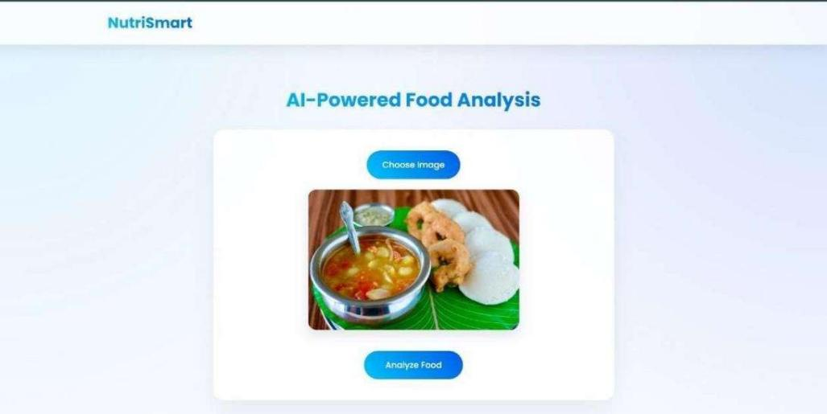

**Fig : 5.3 Analysing Image**

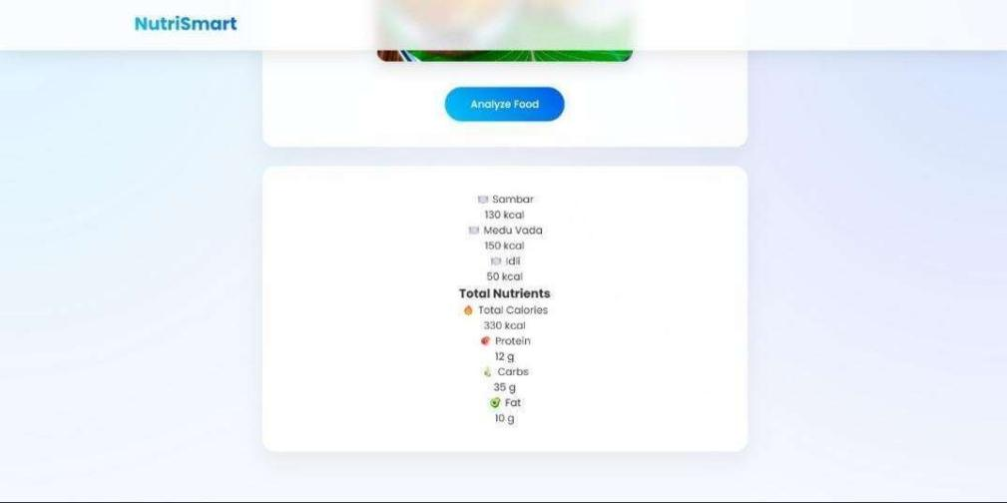

**Fig : 5.4 Calorie and Nutritional values**

## 6.CONCLUSIONS AND FUTURE ENHANCEMENTS

### Summary of Findings

The Food Calorie Detector project was successful in illustrating the ways in which food images could be processed and nutritional information could be given, i.e., calories, proteins, fats, and carbohydrate consumption. Through the utilization of the capabilities of GPT-4o-mini and using it together with a web application made with Flask, the system has a simple interface by which real-time dietary information could be obtained. The project addresses the current demand for automatic nutritional analysis software, particularly in light of the current health-conscious boom worldwide.

One of the most appealing aspects of the project was the fact that it could detect more than a single kind of food in a single image. This feature makes the system more useful as it can be very handy for people who eat mixed food or require an approximate count of total food eaten in a rush. Having GPT-4o-mini onboard enabled strong image processing capability such that even very complex combinations of foods could be processed correctly.

The performance of the model in predicting calories was tested on different datasets, and results showed the system doing its best in actual conditions. Training of the prediction model was done on publicly accessible datasets of food images so that the app can make predictions on the foods accurately. There were certain limitations to the project as well such as a change in image quality, lighting sources, and discovering similar foods.

Also, the project possessed a pleasant web interface nicely done using Flask, HTML, and CSS. The simple interface facilitated easy image upload and instant nutritional analysis. Although the existing project is a colossal leap in using AI for diet tracking, there are quite a few optimizations that can facilitate its enhanced performance, scalability, and usability.

#### Potential Future Improvements or Enhancements

1. **Using Larger and More Varied Datasets**

The functioning of any AI-powered system largely depends on the kind and diversity of the training dataset. While this project used the typically available food

datasets, enlarging the dataset can significantly increase model accuracy. A larger dataset would imply:

* + A more diversified set of food items, like region-specific and culturally unique foods.
  + Various food presentation, i.e., plated, packed, and street food.
  + Various images with various angles, lighting, and resolution to maximize the model's strength.

Having secondary data sources, including government health databases, nutrition research centers, and user-uploaded images, will enhance the model's generalizability to real cases. Images of high resolution must also be utilized, so that more accurate feature extraction is performed and yields more accurate nutrient estimation.

#### Real-Time Image Processing and Updates

Real-time processing for real-world practicality of this system is a necessity. Increased speed in data retrieval and image recognition will contribute significantly to enhanced user experience. Some possible optimizations are:

* + Using image processing algorithm such as OpenCV optimizations.
  + Edge computing usage to run image processing locally on devices of users prior to sending data to the server.
  + usage of neural network architecture such as MobileNet or YOLO to accelerate food classification without decreasing accuracy.

Aside from that, ongoing real-time updating of the model using new data can improve its accuracy. User input and interaction through methods like reinforcement learning or semi-supervised learning can enable the model to change based on interactions.

#### Integration with Mobile Apps for Accessibility

To make the Food Calorie Detector even more user-friendly, mobile app development would be an important milestone. The mobile app would enable users to scan and evaluate food images on a real-time basis without having to upload them to a web- based system. The mobile app would provide the following functionality:

* + **Offline Mode:** To scan and estimate calorie content offline.
  + **Barcode Scanning:** So that the users would be able to scan packaged food for correct nutritional information.
  + **Meal Tracking:** Logging previous analyses so that users can monitor their daily or weekly calorie consumption.
  + **Wearable Integration**: Synchronization with smartwatches and fitness wearables to offer a complete health tracking system.

Having it created as a cross-platform app using such tools as Flutter or React Native would have it available both for Android and iOS, thereby reaching more users.

#### Personalization with AI

Personalization is the second enhancement. Although the system currently gives standardized nutrition data concerning food without an eye on personalized nutrition requirements, personalization modes can range from:

* + **User Profiles:** User input of age, weight, height, activity level, and diet type to have nutrition recommendations based on what they require.
  + **Health Objectives:** Adding capabilities such as weight loss, bulking up, or diabetic meal planning.
  + **AI-Based Meal Suggestions:** Providing alternate meal suggestions based on identified food objects to enable users to make optimal decisions.

With the addition of AI-based nutritional suggestions, the Food Calorie Detector would be an end-to-end well-being and health app instead of a generic image- based calorie calculator.

#### Enhancing Food Detection Capability

The system already identifies popular foods, but it can be enhanced to identify:

* + **Home-Cooked Foods:** Packaged food or restaurant food is all datasets are primarily based on, but home-cooked food is difficult to identify. Training from user-uploaded images of home-cooked food would be more realistic.
  + **Food Portion Estimation**: An estimated amount of food that can be seen in an image needs to be employed to estimate calories properly. Depth estimation and object segmentation algorithms will enable one to incorporate portion size

detection.

* + **Ingredient Segmentation:** Segmentation of combined foods into individual ingredients could assist in rendering the analysis of nutrients more accurate.

#### Multiple Language Support to Facilitate World Accessibility

While expanding the system's application domain, multi-linguality would be a necessity. Various customers within and across places can view the web page in a preferred language, enhancing the user friendliness. Natural Language Processing methods could be employed to aid instant translations of food texts and nutrient disintegrations**.**

#### Inter-working with Nutrition and Health Practitioners

Along with enabling system verification and precision, provision can also be made for physician, dietician, and nutritionist interaction. Professional feedback can confirm appropriateness of estimated calorie values and provide alternatives based on predetermined nutrition standards. Integration of the system in healthcare application can also enable physicians and dietitians to monitor their patients' diet and provide personalized suggestions.

Food Calorie Detector opened the way for food identification and nutrition analysis through the aid of AI. The system being skilled at diet pattern analysis, areas exist where improvement can be taken from datasets and real-time to mobile app interfacing and personalization through AI. If done, the system would be an enhanced and intelligence- based system for diet tracking and thus enhance the capability of users to make sound nutritional decisions.

With advancing technology, diet control in the future would be the intersection of AI, computer vision, and personalized health monitoring. The suggested enhancements would take the Food Calorie Detector to a high-tech device capable of coping with the ever-growing needs of health-aware people around the globe.

## REFERENCES

1. Khamesian, A., Arefeen, M., Carpenter, J., & Ghasemzadeh, H. (2025). NutriGen: Personalized Meal Plan Generator Leveraging Large Language Models to Enhance Dietary and Nutritional Adherence. *MDPI*.
2. O’Hara, K., Kent, M., Flynn, A., Gibney, E., & Timon, C. (2025). An Evaluation of ChatGPT for Nutrient Content Estimation from Meal Photographs. *MDPI*.
3. Guo, X., Liu, Y., Xiang, Z., & An, J. (2025). From AI to the Table: A Systematic Review of ChatGPT’s Potential and Performance in Meal Planning and Dietary Recommendations. *MDPI*.
4. Chen, Y., Wang, Y., & Zhang, L. (2025). An Evaluation of ChatGPT for Nutrient Content Estimation from Meal Photographs. *Nutrients*, *17*(4), 607.
5. Yao, Y., Yao, W., Zhou, L., & Zhang, H. (2024). CaLoRAify: Calorie Estimation with Visual-Text Pairing and LoRA-Driven Visual Language Models. *MDPI*.
6. Papastratis, I., Konstantinidis, A., Daras, P., & Dimitropoulos, K. (2024). AI Nutrition Recommendation Using a Deep Generative Model and ChatGPT. *MDPI*.
7. Lo, F. P.-W., Qiu, J., Wang, Z., Chen, J., Xiao, B., Yuan, W., Giannarou, S., Frost, G., & Lo, B. (2023). *Dietary assessment with multimodal ChatGPT: A systematic analysis* (arXiv:2312.08592). arXiv.